School of Science, Computing and Engineering Technologies

COS30045

LAB 4.1 Design Studio

Overview

In this lab you will be given a sample data set and asked to identify the different data and attribute types. You will also think about some questions about this data set that might be answered by a visualisation.

ardd_fatalities_Jan2020_0.xlsx (download from Canvas)

Download and review this data set before attempting this exercise.

1 Interpreting the data set

Complete the LAB 4.1 Quiz.

2 Visualisation Design

Think of three questions you would like to answer with that require a data visualisation.

For each data question you will need to consider the following:

Which data attributes (columns) do you need to answer this question?

Do you need to transform any of the data?

Does the data type change when you transform the data? If so how.

Make a sketch of how you think your visualisation might look and add to this document.

Your Question 1

Your answer here…

Your Question 2

Your answer here

Your Question 3

Your answer here

Include this file as evidence for your Demonstration 2

1. Which State has the highest crash?
2. State
3. There are no transformations needed in this particular graph.
4. No, the data type does not need any changes
5. Which road users are the highest?
6. Road User
7. No transform is needed in this graph.
8. No, the data type does not need any changes.
9. 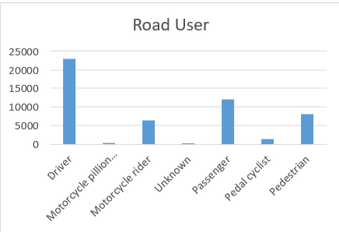
10. Which gender has the highest rate?
11. Gender
12. The data on the x-axis has to be transformed.
13. The -9 was changed to unknown, it can have a better understanding
14. A graph of a person and person

    Description automatically generated